Primary School Mathematics Policy (White Rose Maths)

1. Aims and Rationale
At Treeton, mathematics is a core subject that equips pupils with essential skills for life. We aim to develop confident, resilient mathematicians who can reason logically, think creatively, and apply their knowledge fluently in a range of contexts.
This policy reflects our commitment to high-quality mathematics teaching through the White Rose Maths Scheme, ensuring a coherent, progressive, and mastery-based approach aligned with the National Curriculum.
Our aims are to ensure that all pupils:
• Become fluent in the fundamentals of mathematics
• Reason mathematically using precise language
• Solve problems by applying mathematics to a variety of situations
• Develop a positive attitude towards mathematics and see it as enjoyable and achievable

2. Teaching and Learning Philosophy
We follow a mastery approach to mathematics, underpinned by the principles of White Rose Maths:
• Small steps: Concepts are broken down into carefully sequenced steps to support deep understanding
• Concrete–Pictorial–Abstract (CPA): Pupils progress from hands-on resources, to visual representations, to abstract symbols
• Mathematical talk: Discussion, questioning, and explanation are central to lessons
• Variation: Tasks are carefully designed to deepen understanding rather than accelerate through content
All pupils are encouraged to engage with age-related expectations, with appropriate scaffolding or challenge provided to ensure inclusion and high expectations for all.

3. Curriculum Organisation
Early Years Foundation Stage (EYFS)
In the Early Years Foundation Stage, mathematics is taught in line with the Statutory Framework for the EYFS, with a strong focus on developing a secure foundation in number, numerical fluency, and mathematical language.
We follow the Mastering Number Programme in Reception to support pupils in developing a deep understanding of number. This programme aligns closely with the principles of the White Rose Maths mastery approach and supports children to:
• Develop a secure understanding of numbers to 10
• Subitise and recognise quantities without counting
• Understand the composition of numbers
• Develop fluency through varied and frequent practice
• Use mathematical language confidently through structured talk and play
Mastering Number sessions are taught daily and complement wider mathematics learning through continuous provision, adult-led activities, and high-quality mathematical interactions.
Mathematics learning in EYFS is supported through:
• Play-based and practical experiences
• Concrete resources and manipulatives
• Stories, songs, and rhymes
• Explicit modelling of mathematical vocabulary
• Opportunities for talk and exploration indoors and outdoors
Assessment in EYFS is ongoing and observational, informing next steps and ensuring children are well prepared for the transition into Year 1.

4.Lesson Structure
A typical mathematics lesson includes:
• Recap of prior learning
• Introduction of new learning using CPA
• Guided practice with teacher modelling
• Independent or paired work
• Opportunities for reasoning and problem solving
• Plenary to consolidate and reflect on learning
This is alongside our DSAT Teach Simply Model:
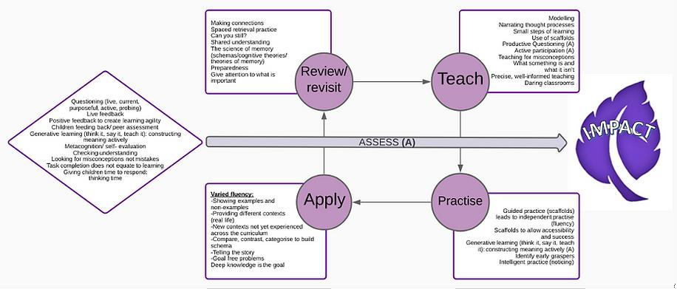
5. Assessment for Learning
Assessment is integral to effective teaching and learning in mathematics.
Formative Assessment:
• Teacher observation
• Questioning
• End-of-block assessments
Summative Assessment:
• Termly assessments
• Statutory assessments

6. Home Learning and Parental Engagement

Parents are encouraged to support mathematics learning through homework, guidance, and workshops.

7. Oracy in Mathematics

Oracy plays a vital role in developing mathematical understanding.
We promote mathematical talk by:
• Teaching and modelling vocabulary
• Encouraging explanation and justification
• Structured partner talk
• Valuing multiple strategies
• Sentence stems and discussion prompts support pupils in explaining their thinking.

Intent, Implementation and Impact
Intent:
To deliver a high-quality, ambitious, and inclusive mathematics curriculum.
Implementation:
Daily mathematics lessons using White Rose Maths and Mastering Number in EYFS, CPA, reasoning, and assessment-informed teaching.
Impact:
Pupils are confident, fluent mathematicians who can explain their thinking and achieve well in assessments.

8. Additional Resources and Schemes
In addition to the White Rose Maths Scheme and Mastering Number in EYFS, the school uses a range of high-quality resources and programmes to further strengthen fluency, problem solving, and retention of key mathematical knowledge.
These include:
- Deconstructing Word Problems (Gareth Metcalfe): Taught daily from Year 2 to Year 6 to explicitly develop pupils’ problem-solving skills. This approach supports pupils in analysing, interpreting, and solving a wide range of word problems with confidence and accuracy.
- Times Tables Booklets (Clare Christie): Completed daily from Year 2 to Year 6 to support rapid recall of multiplication and division facts, building strong foundations for fluency and calculation.
- Reflex (Explore Learning): Used to develop fluency and automaticity in key number facts:
  - Daily in Years 3 and 4 for multiplication
  - Weekly in Key Stage 1 for addition and subtraction
  - Weekly in Years 5 and 6 for multiplication and division
- Flashback 4: Used daily across the school to revisit and retain prior learning, supporting long-term memory and ensuring previously taught concepts remain secure.
- Arithmetic Sessions: Taught weekly to develop confidence and accuracy in formal written calculation methods, aligned with year-group expectations.
- Times Tables Rock Stars: Pupils participate in termly competitions against other DSAT schools to promote engagement, motivation, and fluency in multiplication tables.
These resources complement daily mathematics teaching and ensure pupils develop strong recall, reasoning, and problem-solving skills alongside conceptual understanding.

