**Locational knowledge**

|  |  |  |  |  |  |  |  |
| --- | --- | --- | --- | --- | --- | --- | --- |
| EYFS | | Key Stage One | | Lower Key Stage 2 | | Upper Key Stage 2 | |
| Nursery | Reception | Basic | Advancing (Deep) | Basic | Advancing (Deep) | Basic | Advancing (Deep) |

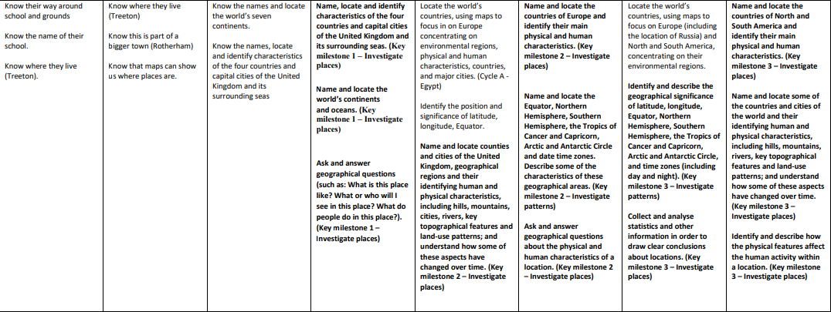

**Place Knowledge**

|  |  |  |  |  |  |  |  |
| --- | --- | --- | --- | --- | --- | --- | --- |
| EYFS | | Key Stage One | | Lower Key Stage 2 | | Upper Key Stage 2 | |
| Nursery | Reception | Basic | Advancing (Deep) | Basic | Advancing (Deep) | Basic | Advancing (Deep) |

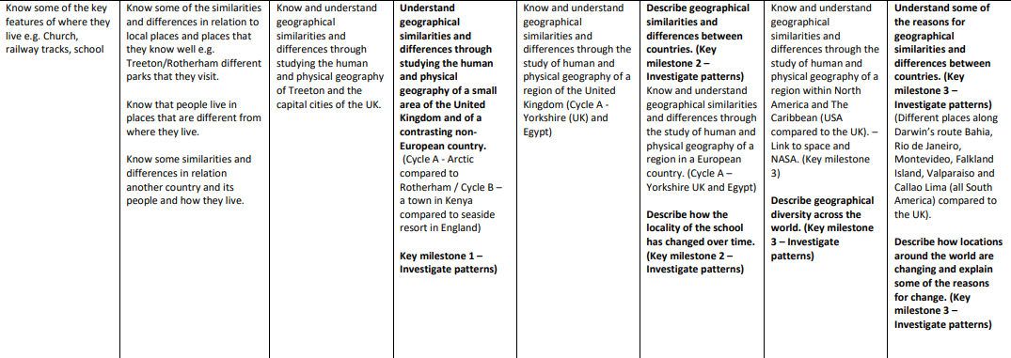

|  |  |  |  |  |  |  |  |
| --- | --- | --- | --- | --- | --- | --- | --- |
| EYFS | | Key Stage One | | Lower Key Stage 2 | | Upper Key Stage 2 | |
| Nursery | Reception | Basic | Advancing (Deep) | Basic | Advancing (Deep) | Basic | Advancing (Deep) |

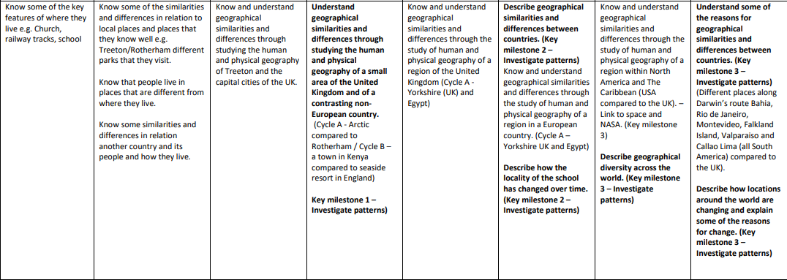

Human and Physical Geography

|  |  |  |  |  |  |  |  |
| --- | --- | --- | --- | --- | --- | --- | --- |
| EYFS | | Key Stage One | | Lower Key Stage 2 | | Upper Key Stage 2 | |
| Nursery | Reception | Basic | Advancing (Deep) | Basic | Advancing (Deep) | Basic | Advancing (Deep) |

