

**Treeton Church of England Primary School**

Maths Calculation Policy

Policy reviewed by: E Wiggett

Subject Leader: E Wiggett

Reviewed: September 2020

Next review: September 2021

|  |  |  |  |
| --- | --- | --- | --- |
| **Objective & Strategy** | **Concrete** | **Pictorial** | **Abstract** |
| Combining two parts to make a whole: part- whole model | Use part part whole model.  Use cubes to add two numbers together as a group or in a bar. | Use pictures to add two numbers together as a group or in  8 1 a bar. | 4 + 3 = 7  5  3  Use the part-part  10= 6 + 4 whole diagram as  shown above to move  into the abstract. |
| Starting at the big- ger number and counting on | Start with the larger number on the bead string and then count on to the smaller number 1 by 1 to find the answer. | 12 + 5 = 17  Start at the larger number on the number line and count on in ones or in one jump to find the answer. | 5 + 12 = 17  Place the larger number in your head and count on the smaller number to find your answer. |
| Regrouping to make 10.  *This is an essential skill for column addition later.* | 6 + 5 = 11  Start with the bigger number and use the smaller number to make 10.  Use ten frames. | Use pictures or a number line. Regroup or partition the smaller number using the part part whole model to make 10. | 7 + 4= 11  If I am at seven, how many more do I need to  make 10. How many more do I add on now? |
| Represent & use number bonds and related subtraction facts within 20 | 2 more than 5. |  | Emphasis should be on the language  ‘*1 more than 5 is equal to 6.’ ‘2 more than 5 is 7.’*  *‘8 is 3 more than 5.’* |

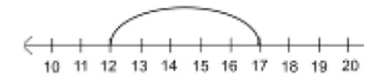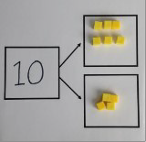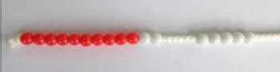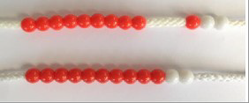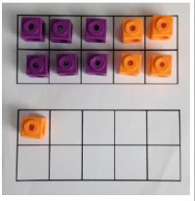

**Y1**

**ADDITION +**

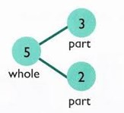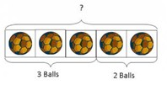

|  |  |  |  |
| --- | --- | --- | --- |
| **Objective &**  **Strategy** | **Concrete** | **Pictorial** | **Abstract** |
| Adding multiples of ten | 50= 30 = 20    Model using dienes and bead strings | Use representations for base ten. | 20 + 30 = 50  70 = 50 + 20  40 + □ = 60 |
| Use known number facts  Part part whole | Children explore ways of making numbers within 20 |  |  |
| Using known facts | + =  + = | Children draw representations of H,T and O |  |
| Bar model | 3 + 4 = 7 | 7 + 3 = 10 | 23 + 25 = 48 |

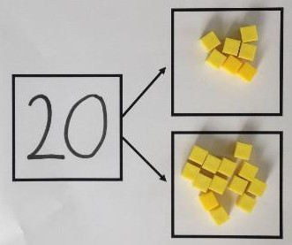

**Y2**

**ADDITION +**



|  |  |  |  |
| --- | --- | --- | --- |
|  |  |  |  |

|  |  |  |  |
| --- | --- | --- | --- |
| **Objective &**  **Strategy** | **Concrete** | **Pictorial** | **Abstract** |
| Add a two digit number and ones | 17 + 5 = 22  Use ten frame to make ‘magic ten  Children explore the pattern. 17 + 5 = 22  27 + 5 = 32 | 17 + 5 = 22  Use part  part whole  and number  line to  model. | 17 + 5 = 22  Explore related facts  17 + 5 = 22  5 + 17 = 22  22  22—17 = 5  17 5  22—5 = 17 |
| Add a 2 digit num- ber and tens | 25 + 10 = 35  Explore that the ones digit does not change |  | 27 + 10 = 37  27 + 20 = 47  27 + □ = 57 |
| Add two 2-digit  numbers | Model using dienes , place value counters and numicon | Use number line and bridge ten using part whole if necessary. | 25 + 47  20 + 5 40 + 7  20 + 40 = 60  5+ 7 =12  60 + 12 = 72 |
| Add three 1-digit numbers | Combine to make 10 first if possible, or bridge 1o then add third digit | + +  Regroup and draw representation.  + = 15 | Combine the two numbers that make/ bridge ten then add on the third. |

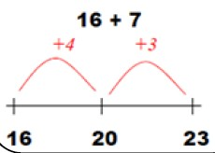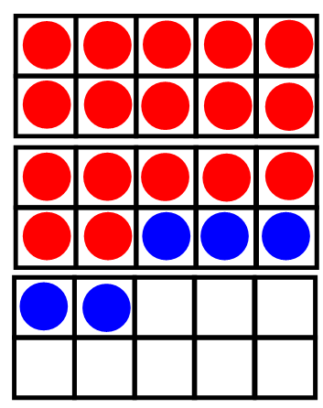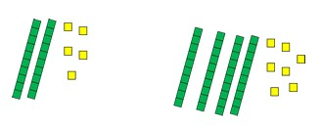

**Y2**

**ADDITION +**



|  |  |  |  |
| --- | --- | --- | --- |
| **Objective &**  **Strategy** | **Concrete** | **Pictorial** | **Abstract** |
| Column Addition—no regrouping (friendly numbers)  Add two or three 2 or 3- digit numbers. | Model using Dienes or numicon  Add together the ones first, then the tens.    Move to using place value counters | Children move to drawing the counters using a tens and one frame.  tens ones | 2 2 3  + 1 1 4  3 3 7  Add the ones first, then the tens, then  the hundreds. |
| Column Addition with regrouping. | Exchange ten ones for a ten. Model using numicon and pv counters. | Children can draw a representation of the grid to further support their understanding, carrying the ten **underneath** the line | Start by partitioning the numbers before formal column to show the exchange. |

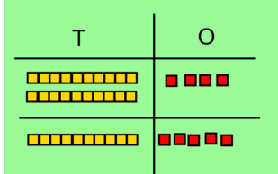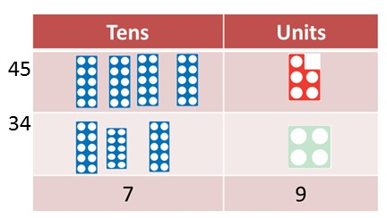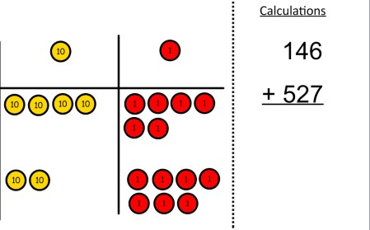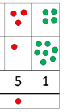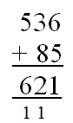

**Y3**

**ADDITION +**

**ADDITION**



|  |  |  |  |
| --- | --- | --- | --- |
| **Objective &**  **Strategy** | **Concrete** | **Pictorial** | **Abstract** |
| Y4—add numbers with up to 4 digits | Children continue to use dienes or pv counters to add, exchanging ten ones for a ten and ten tens for a hundred and ten hundreds for a thousand. | Draw representations using pv grid. | Continue from previous work to carry hundreds as well as tens.  Relate to money and measures. |
| Y5—add numbers with  more than 4 digits.  Add decimals with 2 decimal places, including money. | As year 4  tens ones tenths hundredths  Introduce decimal place value counters  and model exchange for addition. |  |  |
| Y6—add several numbers of increasing complexity  Including adding money, measure and decimals with different numbers of decimal points. | As Y5 | As Y5 | Insert zeros for place holders. |

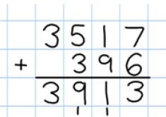

**Y4-6**



**ADDITION +**

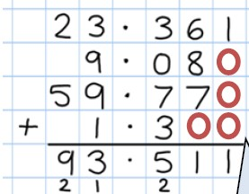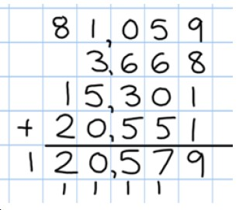

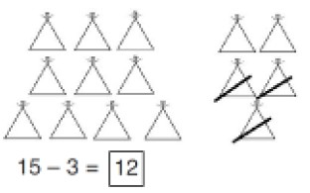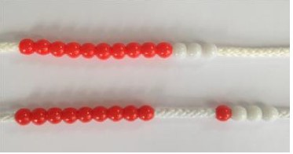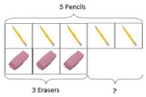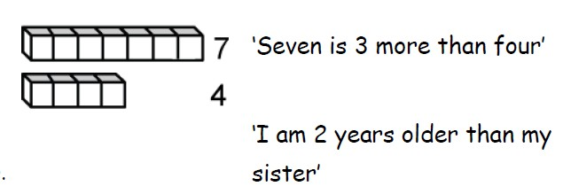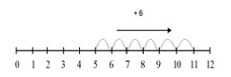

**SUBTRACTION -**

**Y1**

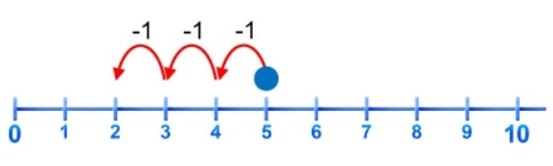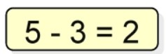

|  |  |  |  |
| --- | --- | --- | --- |
| **Objective & Strategy** | **Concrete** | **Pictorial** | **Abstract** |
| Taking away ones. | Use physical objects, counters , cubes etc to show how objects can be taken away.  6—4 = 2  4—2 = 2 | Cross out drawn objects to show what has been taken away. | 7—4 = 3  16—9 = 7 |
| Counting back | Move objects away from the group, counting backwards.  Move the beads along the bead string as you count backwards. | Count back in ones using a number line. | Put 13 in your head, count back 4. What number are you at? |
| Find the Difference | Compare objects and amounts    Lay objects to represent bar model. | Count on using a number line to find the difference. | Hannah has 12 sweets and her sister has 5. How many more does Hannah have than her sister.? |

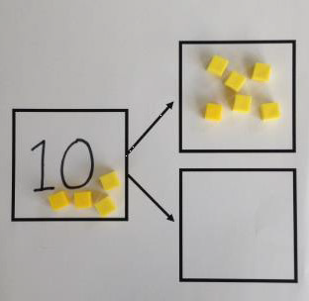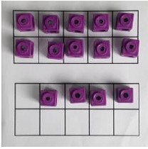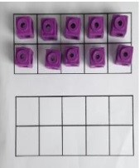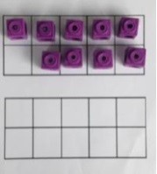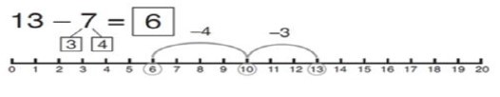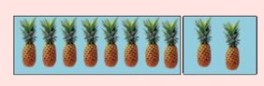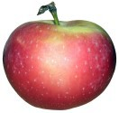





7

12

5

**SUBTRACTION -**

**Y1**

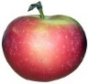

|  |  |  |  |  |
| --- | --- | --- | --- | --- |
| **Objective &**  **Strategy** | **Concrete** | **Pictorial** | **Abstract** |  |
| **Represent and use number bonds and related subtraction facts within 20**  Part Part Whole model | Link to addition. Use PPW model to model the inverse.  If 10 is the whole and 6 is one of the arts, what s the other part?  10—6 = 4 | Use pictorial representations to show the part. | Move to using numbers within the part whole model. |  |
| Make 10 | 14—9    Make 14 on the ten frame. Take 4 away to make ten, then take one more away so that you have taken 5. | 13—7    Jump back 3 first, then another 4. Use ten as the stopping point. | 16—8  How many do we take off first to get to 10? How many left to take off? |  |
| Bar model | 5—2 = 3 |  | 8 2  10 = 8 + 2  10 = 2 + 8  10—2 = 8  10—8 = 2 |  |

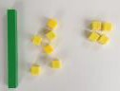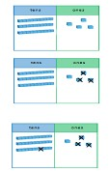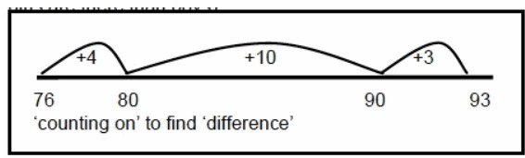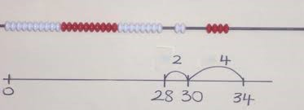

**Y2**

**SUBTRACTION -**



|  |  |  |  |
| --- | --- | --- | --- |
| **Objective & Strategy** | **Concrete** | **Pictorial** | **Abstract** |
| Regroup a ten into ten ones | Use a PV chart to show how to change a ten into ten ones, use the term ‘take and make’ |  | 20—4 = 16 |
| Partitioning to sub- tract without re- grouping.  *‘Friendly numbers’* | 34—13 = 21  Use Dienes to show how to partition the number when subtracting without regrouping. | Children draw representations of Dienes and cross off.  43—21 = 22 | 43—21 = 22 |
| Make ten strategy  *Progression should be crossing one ten, crossing more than one ten, crossing the hundreds.* | 34—28  Use a bead bar or bead strings to model counting to next ten and the rest. | Use a number line to count on to next ten and then the rest. | 93—76 = 17 |
|  |  |  |  |

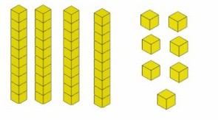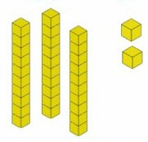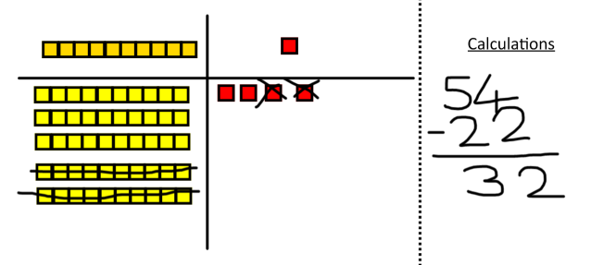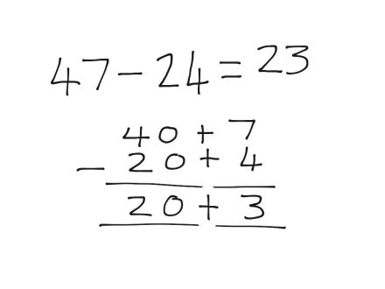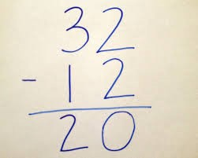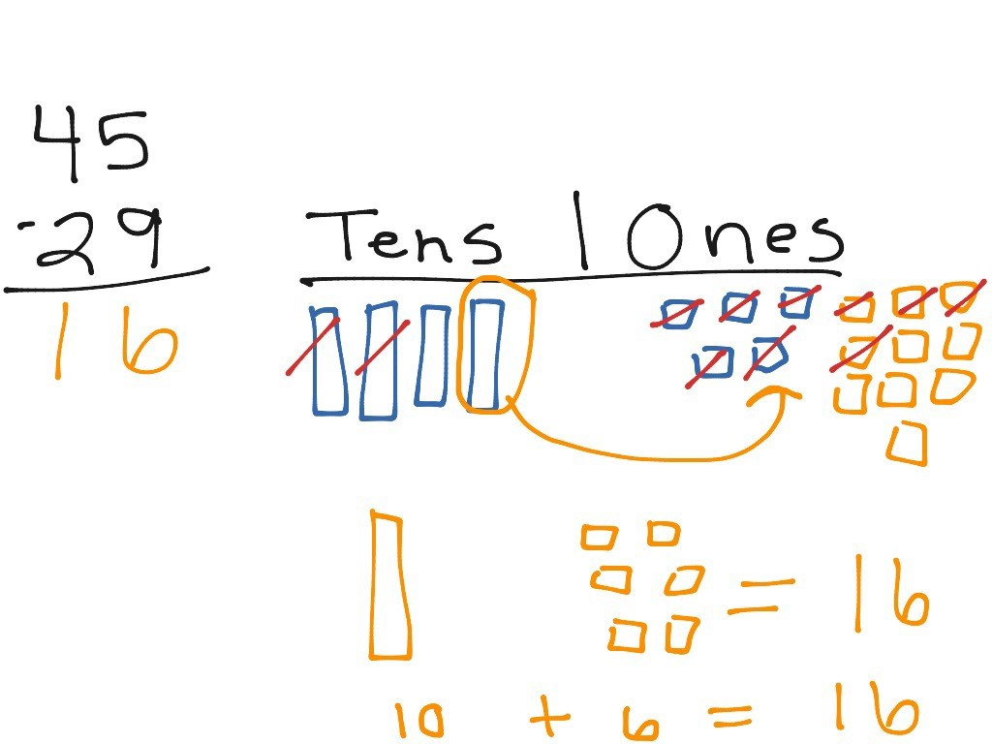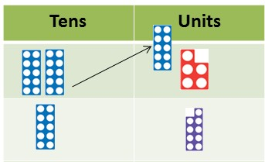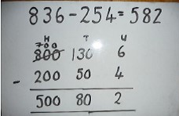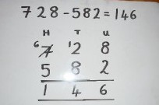

**Y3**

**SUBTRACTION -**

|  |  |  |  |
| --- | --- | --- | --- |
| **Objective &**  **Strategy** | **Concrete** | **Pictorial** | **Abstract** |
| Column subtraction without regrouping (friendly numbers) | 47—32  —  Use base 10 or Numicon to model | Darw representations to support under- standing | Intermediate step may be needed to lead to clear subtraction under- standing. |
| Column subtraction with regrouping | Begin with base 10 or Numicon. Move to pv counters, modelling the exchange of a ten into ten ones. Use the phrase ‘take and make’ for exchange. | Children may draw base ten or PV counters and cross off. | Begin by partitioning into pv columns  Then move to  formal method. |
|  |  |  |  |

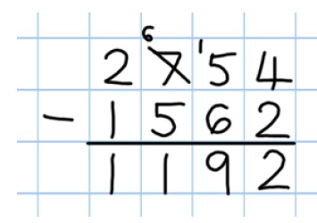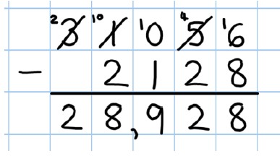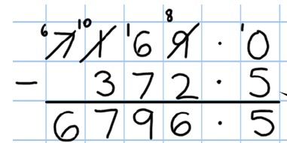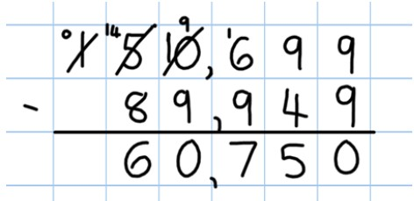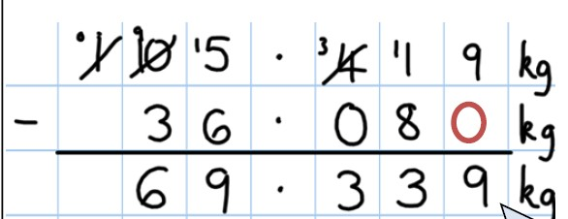

**SUBTRACTION -**

**Y4-6**

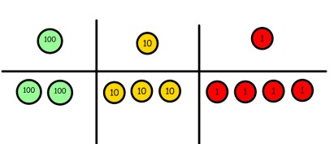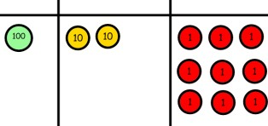

|  |  |  |  |
| --- | --- | --- | --- |
| **Objective &**  **Strategy** | **Concrete** | **Pictorial** | **Abstract** |
| Subtracting tens and ones  Year 4 subtract with  up to 4 digits.  *Introduce decimal subtraction through context of money* | 234 - 179  Model process of exchange using Numicon, base ten and then move to PV counters. | Children to draw pv counters and show their exchange—see Y3 | Use the phrase ‘take and make’ for ex- change |
| Year 5- Subtract with at least 4 dig- its, including money and measures.  *Subtract with decimal values, including mixtures of integers and decimals and aligning the decimal* | As Year 4 | Children to draw pv counters and show their exchange—see Y3 | Use zeros for place- holders. |
| Year 6—Subtract with increasingly large and more complex numbers and decimal values. |  |  |  |

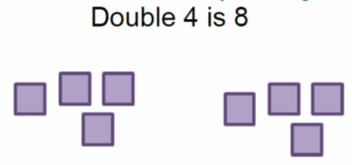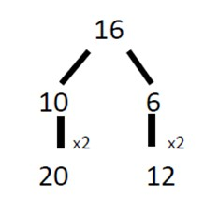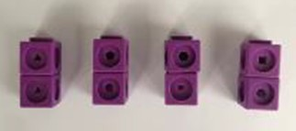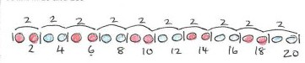

**MULTIPLICATION X**

**Y1**

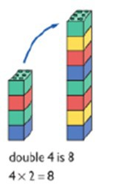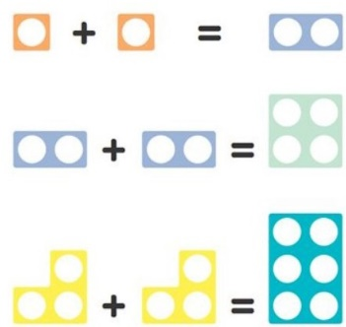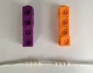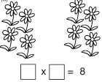

|  |  |  |  |
| --- | --- | --- | --- |
| **Objective &**  **Strategy** | **Concrete** | **Pictorial** | **Abstract** |
| Doubling | Use practical activities using manipultives including cubes and Numicon to demonstrate doubling | Draw pictures to show how to double numbers | Partition a number and then double each part before recombining it back together.  + = 32 |
| Counting in multiples | Count the groups as children are skip |  | Count in multiples of a number aloud. |
| multiples | counting, children may use their fingers as they are skip counting. |  | Write sequences with multiples of numbers. |
|  |  |  |  |
|  |  | Children make representations to show |  |
|  |  | counting in multiples. |  |
|  |  |  | 2, 4, 6, 8, 10 |
|  |  |  | 5, 10, 15, 20, 25 , 30 |
| Making equal groups and counting the total | Use manipulatives to create equal groups. | Draw and make representations | 2 x 4 = 8 |

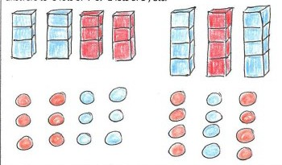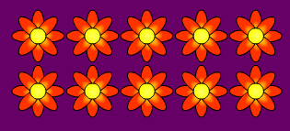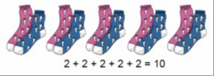

**MULTIPLICATION X**

**Y1**

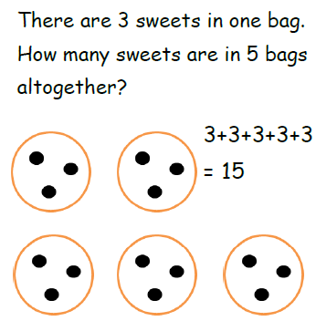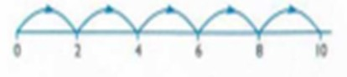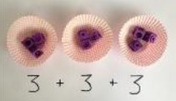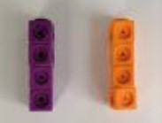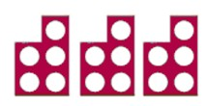

|  |  |  |  |
| --- | --- | --- | --- |
| **Objective &**  **Strategy** | **Concrete** | **Pictorial** | **Abstract** |
| Repeated addition | Use different objects to add  equal groups | Use pictorial including number lines to solve problems | Write addition sentences to describe objects and pictures. |
| Understanding arrays | Use objects laid out in arrays to find the answers to 2 lots 5, 3 lots of 2 etc. | Draw representations of arrays to show under- standing | 3 x 2 = 6  2 x 5 = 10 |
|  |  |  |  |

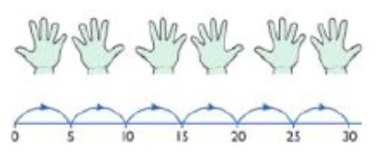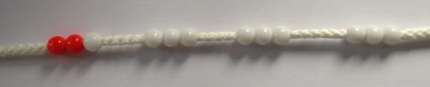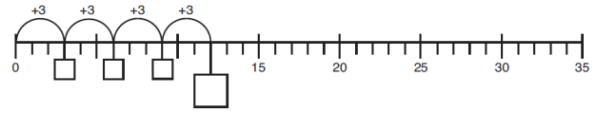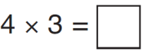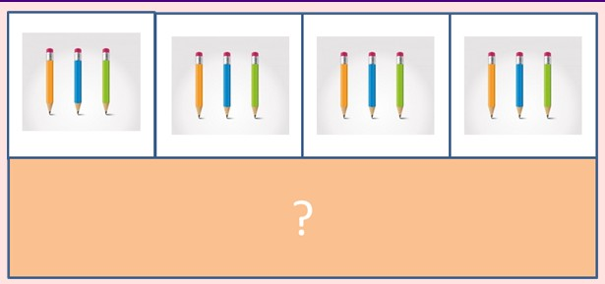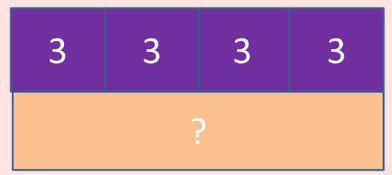

**MULTIPLICATION X**

**Y2**



|  |  |  |  |
| --- | --- | --- | --- |
| **Objective & Strategy** | **Concrete** | **Pictorial** | **Abstract** |
| Doubling | Model doubling using dienes and PV counters.  40 + 12 = 52 | Draw pictures and representations to show how to double numbers | Partition a number and then double each part before recombining it back together.  + = 32 |
| Counting in multiples | Count the groups as children are skip | Number lines, counting sticks and bar | Count in multiples of a number aloud. |
| Multiples of 2, 3, 4, 5, 10 | counting, children may use their fingers | models should be used to show representation |  |
| from 0 | fingers as they are skip counting. Use bar | representation of counting in multiples. |  |
| (repeated addition) | models. |  | Write sequences with multiples of  numbers. |
|  | 5 + 5 + 5 + 5 + 5 + 5 + 5 + 5 = 40 |  | 0, 2, 4, 6, 8, 10 |
|  |  |  | 0, 3, 6, 9, 12, 15 |
|  |  |  | 0, 5, 10, 15, 20, 25 , 30 |

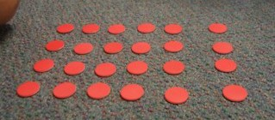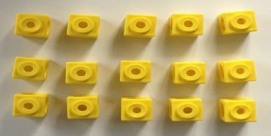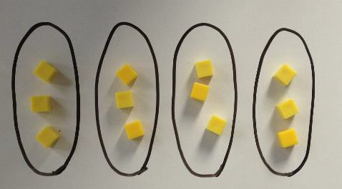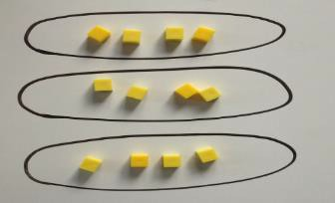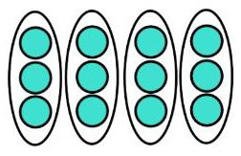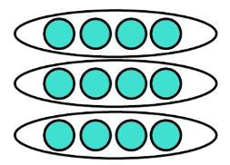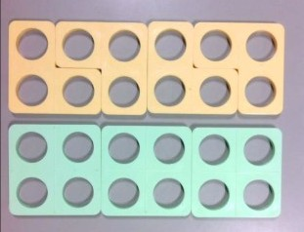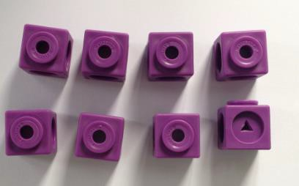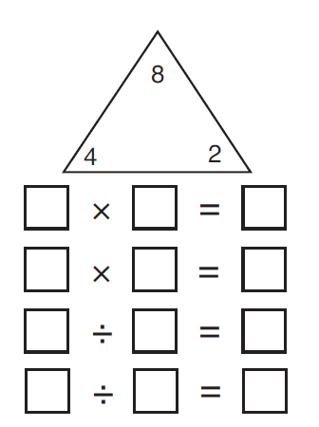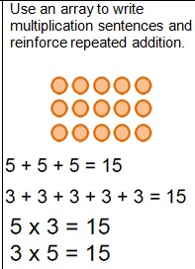

**MULTIPLICATION X**

**Y2**

|  |  |  |  |
| --- | --- | --- | --- |
| **Objective & Strategy** | **Concrete** | **Pictorial** | **Abstract** |
| Multiplication is commutative | Create arrays using counters and cubes and  Numicon.    Pupils should understand that an array can represent different equations and that, as multiplication is commutative, the order of the multiplication does not affect the answer. | Use representations of arrays to show different calculations and explore commutativity. | 12 = 3 × 4  12 = 4 × 3 |
| Using the Inverse  *This should be taught alongside division, so pupils learn how they work alongside each other.* |  |  | 2 x 4 = 8  4 x 2 = 8  8 ÷ 2 = 4  8 ÷ 4 = 2  8 = 2 x 4  8 = 4 x 2  2 = 8 ÷ 4  4 = 8÷ 2  Show all 8 related fact family sentences. |

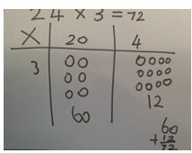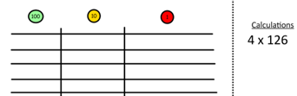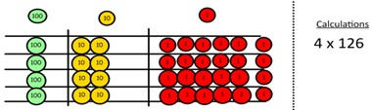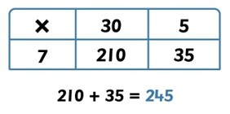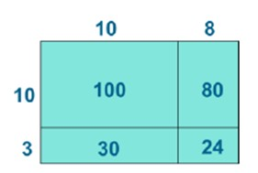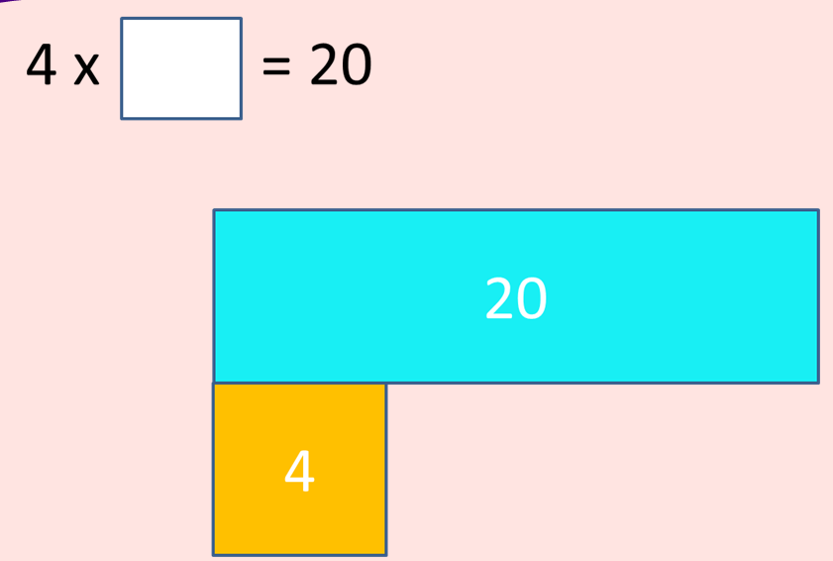

**Y3**

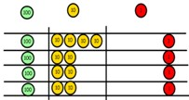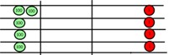

|  |  |  |  |
| --- | --- | --- | --- |
| **Objective &**  **Strategy** | **Concrete** | **Pictorial** | **Abstract** |
| Grid method | Show the links with arrays to first intro- duce the grid method.    Move onto base ten to move towards a more compact method.  Move on to place value counters to show how we are finding groups of a number. We are multiplying by 4 so we need 4 rows  Fill each row with 126  Add up each column, starting with the ones making any exchanges needed  Then you have your answer. | Children can represent their work with place value counters in a way that they understand.  They can draw the counters using colours to show different amounts or just use the circles in the different columns to show their thinking as shown below.  Bar model are used to explore missing numbers | Start with multiplying by one digit numbers and showing the clear addition alongside the grid.    Moving forward, multiply by a 2 digit number showing the different rows within the grid method. |

**MULTIPLICATION X**

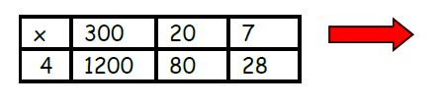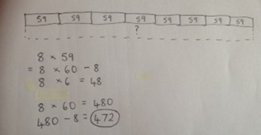

**MULTIPLICATION X**

**Y4**

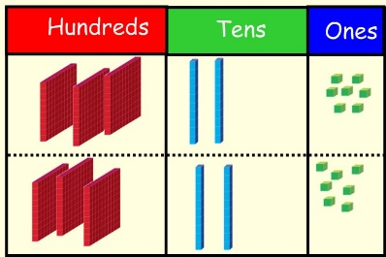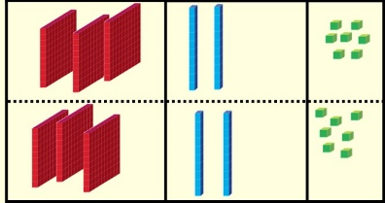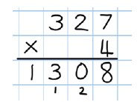

|  |  |  |  |
| --- | --- | --- | --- |
| **Objective & Strategy** | **Concrete** | **Pictorial** | **Abstract** |
| Grid method recap from year 3 for 2 digits x 1 digit  Move to multiplying 3 digit numbers by 1 digit. (year 4 expectation) | Use place value counters to show how we are  finding groups of a number. We are multiplying by 4 so we need 4 rows    Fill each row with 126    Add up each column, starting with the ones making any exchanges needed | Children can represent their work with place value counters in a way that they understand.  They can draw the counters using colours to show different amounts or just use the circles in the different columns to show their thinking as shown below. | Start with multiplying by one digit numbers and showing the clear addition alongside the grid. |
| Column multiplication | Children can continue to be supported by place value counters at the stage of multiplication. This initially done where there is no regrouping. 321 x 2 = 642  It is important at this stage that they always multiply the ones first.  The corresponding long multiplication is modelled alongside. | The grid method my be used to show how this relates to a formal written method.    Bar modelling and number lines can support learners when solving problems with multiplication alongside the formal written methods. | 327  x 4  28  80  1200  1308  This may lead to a compact method. |

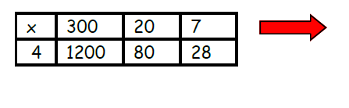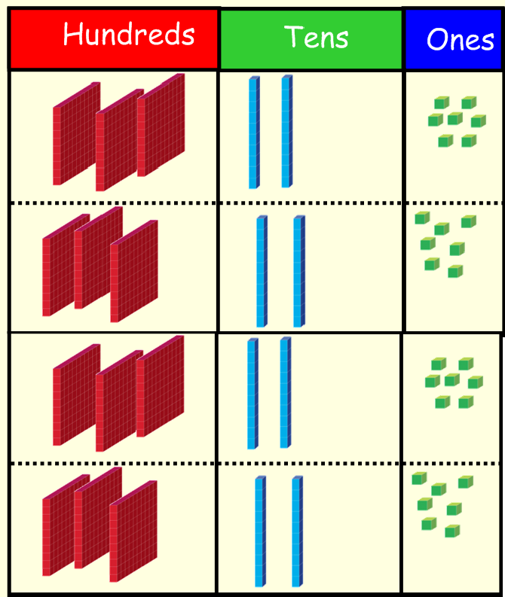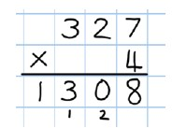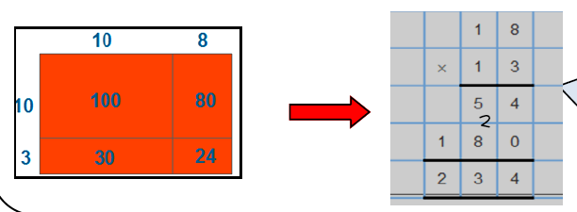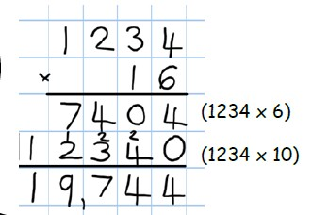

**MULTIPLICATION X**

**Y5-6**

|  |  |  |  |
| --- | --- | --- | --- |
| **Objective &**  **Strategy** | **Concrete** | **Pictorial** | **Abstract** |
| Column Multiplication for 3 and 4 digits x 1 digit. | It is important at this stage that they always multiply the ones first.  Children can continue to be supported by place value counters at the stage of multiplication. This initially done where there is no regrouping. 321 x 2 = 642 |  | 327  x 4  28  80  1200  1308  This will lead to a compact method. |
| Column multiplication | Manipulatives may still be used with the corresponding long multiplication modelled alongside. | Continue to use bar modelling to support problem solving | 18 x 3 on the first row  (8 x 3 =24, carrying the 2 for 20, then 1 x 3)  18 x 10 on the 2nd row. Show  multiplying by 10 by putting zero in units first |

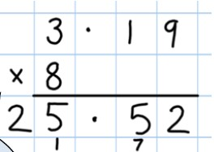

**MULTIPLICATION X**

**Y6**

|  |  |  |  |
| --- | --- | --- | --- |
| **Objective &**  **Strategy** | **Concrete** | **Pictorial** | **Abstract** |
| Multiplying decimals up to 2 decimal places by a single digit. |  |  | Remind children that the single digit belongs in the units column. Line up the decimal points in the question and the answer. |

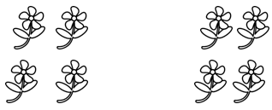

**DIVISION ÷**

**Y1**

|  |  |  |  |
| --- | --- | --- | --- |
| **Objective &**  **Strategy** | **Concrete** | **Pictorial** | **Abstract** |
| Division as sharing  *Use Gordon ITPs for*  *modelling* | I have 10 cubes, can you share them equally in 2 groups? | Children use pictures or shapes to share quantities  8 shared between 2 is 4 | 12 shared between 3 is 4 |

|  |  |  |  |
| --- | --- | --- | --- |
| **Objective &**  **Strategy** | **Concrete** | **Pictorial** | **Abstract** |
| Division as sharing | I have 10 cubes, can you share them equally in 2 groups? | Children use pictures or shapes to share quantities.    Children use bar modelling to show and support understanding.    12 ÷ 4 = 3 | 12 ÷ 3 = 4 |
| Division as grouping | Divide quantities into equal groups.  Use cubes, counters, objects or place value counters to aid understanding. | Use number lines for grouping    Think of the bar as a whole. Split it into the number of groups you are dividing by and work out how many would be within each group. | 28 ÷ 7 = 4  Divide 28 into 7 groups. How many are in  each group? |

**DIVISION ÷**

**Y2**



|  |  |  |  |
| --- | --- | --- | --- |
| **Objective &**  **Strategy** | **Concrete** | **Pictorial** | **Abstract** |
| Division as grouping | Use cubes, counters, objects or place value counters to aid understanding.    24 divided into groups of 6 = 4 | Continue to use bar modelling to aid solving division problems. | How many groups of 6 in 24?  24 ÷ 6 = 4 |
| Division with arrays | Link division to multiplication by creating an array and thinking about the number sentences that can be created.  Eg 15 ÷ 3 = 5 5 x 3 = 15  15 ÷ 5 = 3 3 x 5 = 15 | Draw an array and use lines to split the array into groups to make multiplication and division sentences | Find the inverse of multiplication and division sentences by creating eight linking number sentences.  7 x 4 = 28  4 x 7 = 28  28 ÷ 7 = 4  28 ÷ 4 = 7  28 = 7 x 4  28 = 4 x 7  4 = 28 ÷ 7  7 = 28 ÷ 4 |

**DIVISION ÷**

**Y3-4**

|  |  |  |  |
| --- | --- | --- | --- |
| **Objective &**  **Strategy** | **Concrete** | **Pictorial** | **Abstract**  **Y3-4** |
| Division with remainders. | 14 ÷ 3 =  Divide objects between groups and see how much is left over | Jump forward in equal jumps on a number line then see how many more you need to jump to find a remainder.    Draw dots and group them to divide an amount and clearly show a remainder.    Use bar models to show division with remainders. | Complete written divisions and show the remainder using r. |

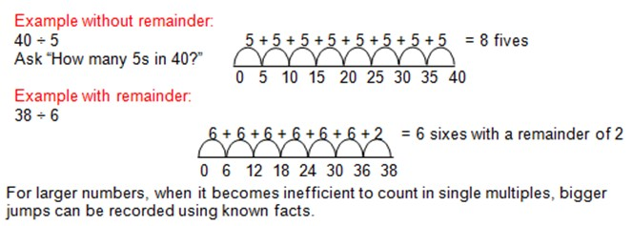

**DIVISION ÷**

|  |  |  |  |
| --- | --- | --- | --- |
| **Objective &**  **Strategy** | **Concrete** | **Pictorial** | **Abstract** |
| Divide at least 3 digit numbers by 1 digit.  Short Division | 96 ÷ 3  Use place value counters to divide using the bus stop method alongside  42 ÷ 3=  Start with the biggest place value, we are sharing 40 into three groups. We can put 1 ten in each group and we have 1 ten left over.    We exchange this ten for ten ones and then share the ones equally among the groups.  We look how much in 1 group so the answer is 14. | Students can continue to use drawn diagrams with dots or circles to help them divide numbers into equal groups.    Encourage them to move towards counting in multiples to divide more efficiently. | Begin with divisions that divide equally with no remainder.    Move onto divisions with a remainder.    Finally move into decimal places to divide the total accurately. |

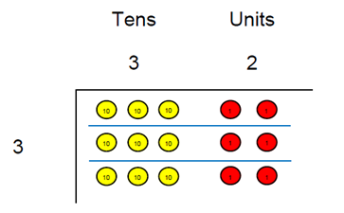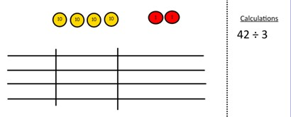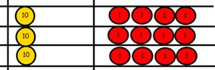

**DIVISION ÷**

**Y5-6**



|  |
| --- |
| **Long Division** |
| Step 1—a remainder in the ones |

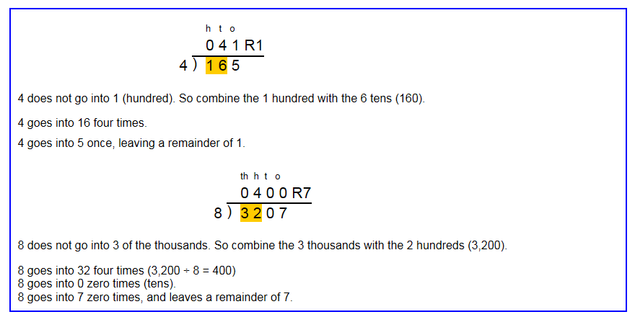

**Y6**

**DIVISION ÷**



|  |
| --- |
| **Long Division** |
| Step 1 continued... |

**DIVISION ÷**

**Y6**

|  |
| --- |
| **Long Division** |
| Step 2—a remainder in the tens |

**DIVISION ÷**

**Y6**

|  |
| --- |
| **Long Division** |
| Step 2—a remainder in any of the place values  **DIVISION ÷** |